**FACE DETECTION**

**Prepared by:**

**Kamil Çoban 20180808060**

**Agah Berkin Güler 20180808035**

**Yavuzhan Güler 20190808070**

**Metehan Ünal 20190808022**

**INTRODUCTION TO FACE DETECTION**

In our age and time, video and image databases have grown tremendously, so we need computers to automatically understand and examine information.The human face is important for social interactions because it reflects the emotions and intents of that person. As a result, automatic face detection systems play a crucial part in face recognition, facial expression recognition, human-computer interactions and other types of applications.

Face detection is an Artificial Intelligence technology that identifies human faces’ locations and their sizes in photographs and is used in a variety of applications. It’s a challenging problem in image processing. It is the base for all face analysis algorithms. Computers need to understand human faces. Computers cannot understand and identify human faces like humans do.

The primary target of face detection should be to determine if there are any faces in a given image.

The difficulty of this task can be from multiple reasons like image scale, location of the face, lighting etc. This topic will be explained later in this report.

Some example applications for face detection are:

**Facial Recognition Technology**

Facial recognition system is a technology that can match a human face from a digital image or video frame against a database of faces. It is often used to verify users via ID verification services and works by locating and measuring facial features from a given image. It's used in video surveillance, human-computer interfaces, and picture database management.

This technology is also used by recent smartphones for increased security.

**Photography**

Recent digital cameras and smartphones have adapted the use of facial detection for automatic detecting and focusing on human faces.

**Advertisement**

Any person that is spotted by a camera will be taken into account by the system. Upon collecting the required data, the system can advertise products related to that person.

**Emotion Recognition**

Facial detection can be used for recognizing human emotions in human faces.

**Speech Recognition**

This technology helps computer systems determine who is talking in the video/picture.

**Gender Recognition**

A humans gender can be determined from an image

**Feature determining**

Features of a human face like eyes, mouth, nose, skin etc. can be determined from an image

**THE DIFFICULTY OF DETECTING FACES**

metin, tablo içeren bir resim

Açıklama otomatik olarak oluşturuldu

“Automatic face detection with OpenCV” (src: wikipedia.org)

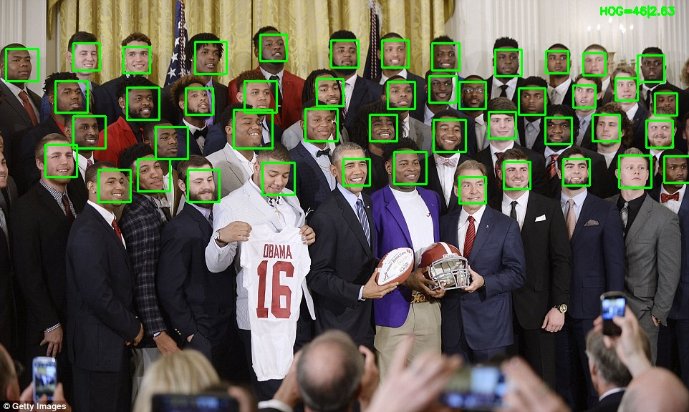

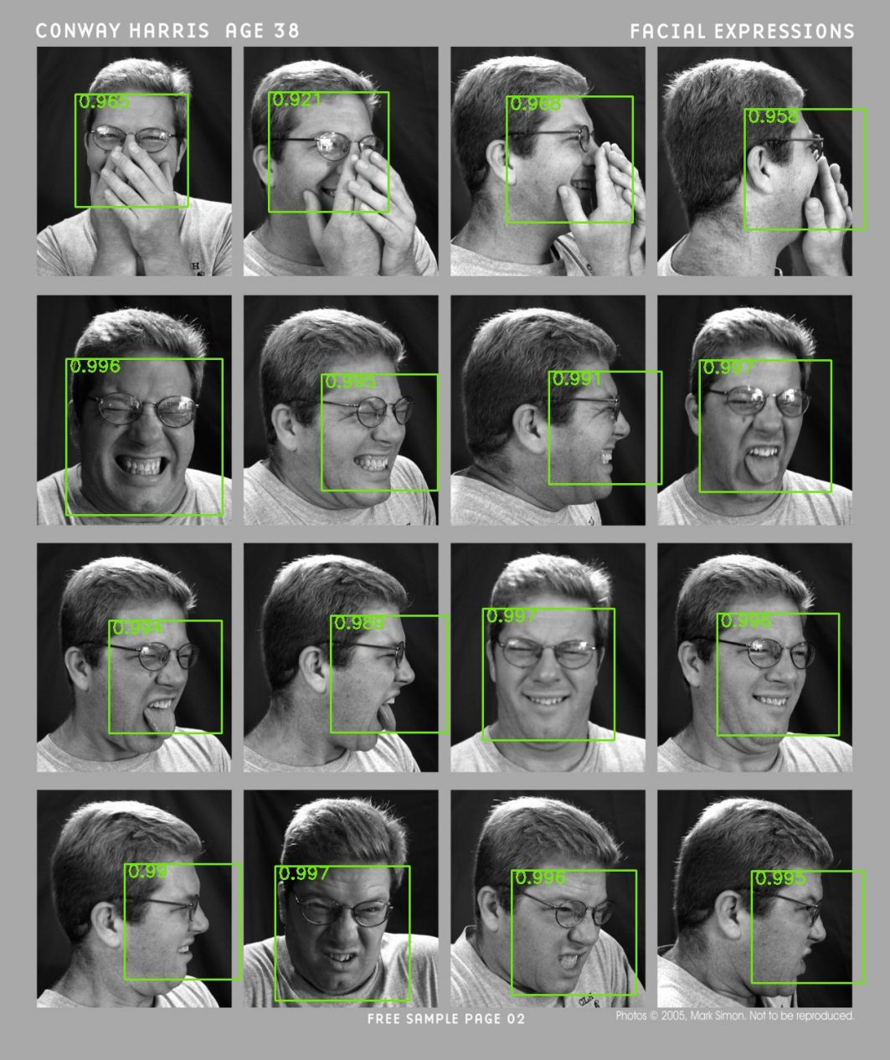

metin, kişi, iç mekan içeren bir resim

Açıklama otomatik olarak oluşturuldu

Src:pathpartnertech.com

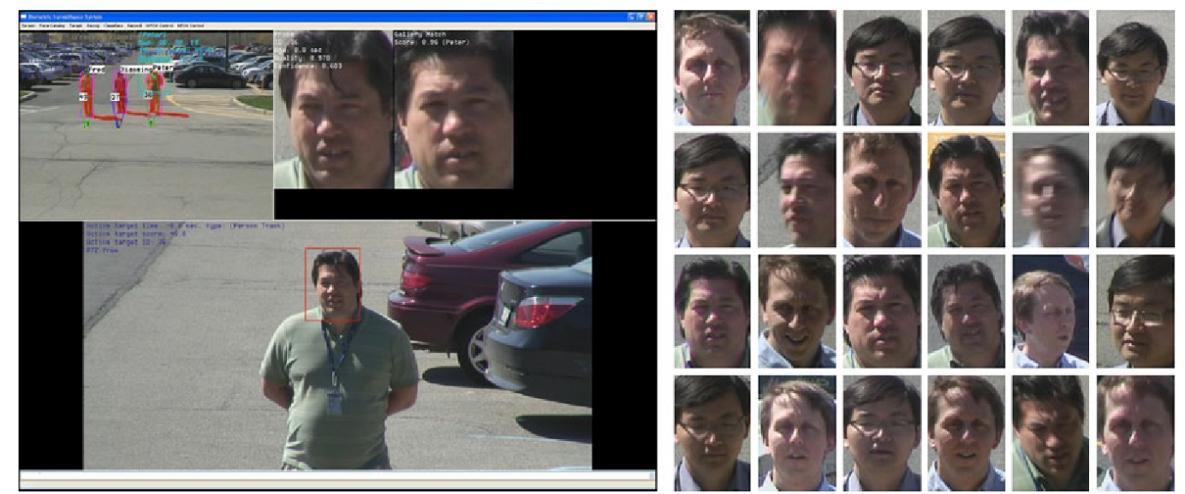

Detecting a human face from a given image can be challenging for systems for a couple of reasons.

These reasons could be:

**Pose** The different variations of poses in human faces may result in failed recognition.

**Expression** The face of a human in the image can have an unusual expression, the system may not pick up the face of a sad/angry/happy person.

**Obstruction** The persons face in a given image may be obstructed by an object. If the person is wearing glasses, or have their hand in front of their face, the computer may have problems finding the face.

**Lighting** Poor illumination may result the computer not being able to find the human face

**Resolution** Bad resolution of an image may result in difficulty for the computer

**So many faces** The image may have too many faces for the system to handle.

**Skin color** can also be a problem for a computer, it may not detect the face of an Asian or a Black person due to skin color difference.

**FACE DETECTION METHODS**

In this chapter we have four different categories for face detection methods. These are:

**Knowledge-Based**

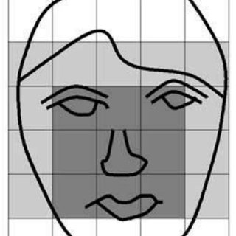The knowledge-based method is subject to a number of rules. This subject is based on human knowledge to detect the faces. For example, a face usually come in an image with two symmetric eyes, a nose, and a mouth. The connection between features can be represented by their positions and distances. The problem is with this method is hard to find the perfect rule settings. If the rules are detailed, they may fail to detect faces. If the rules are too general, they might give false information. Further to that, it is more difficult to extends this attitude to detect faces in different poses. This method aims for face localization.

**Feature-Based**

Feature-based method involves finding structural features that exist even when the level of lightning, pose, shadows, or viewing angle change, and then using them to find faces. This method aims for face localization. This approach divided into four steps. These are Facial Features, Texture, Skin Colour and Multiple Features.  
 *Facial Features* is about using common distance to find the connection between facial features in an image.  
 *Texture* is for separating human faces from other objects.  
 *Skin Colour* is truly important information to face localization but in different level of lighting, it becomes not useful.  
 *Multiple Features* is about combination of shape and colour.

**Template Matching**

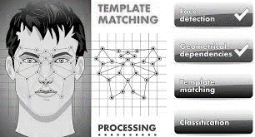Template Matching method uses predefined or parameterized face templates to locate or detect faces by correlating the patterns and the input images. For example, a human face can be separated into eyes, facial outline, nose, and mouth. Additionally, a face model can be constructed from edges simply by using the edge detection method. This approach is simple to implement but is not enough for face detection. However, deformable templates have been proposed to solve these problems.  
 *Predefined Templates* is about using several sub-templates for facial features. All sub-templates are described as terms of line segments. After some process to lines in the input image are matched against the sub-templates. The connection between sub-images and templates are executed at first place to observe candidate locations of human faces.  
 *Deformable Templates* is using to ideal facial features that fit a possible elastic model to facial features. In this approach, facial features are defined by parameterized templates. An energy function identifies by link edges, peaks, and valleys in the input image to comparable parameters in the templates. The finest way through to fit the elastic model is organize by reducing an energy function of the parameters. However, this approach has a disadvantage which is the deformable templates have to started in the proximity of the object of interest.

**Appearance-Based**

Appearance-Based method is subject to on numbers of delegate training face images to find out face models. This method builds up techniques from statical analysis and machine learning to experience the related characteristics of face images. This method also aims for face recognition. This appearance-based method has several sub-methods for the face detection. These are Eigenface Based, Distribution Based, Neural Networks, Support Vector Machine, Sparse Network of Winnows, Naïve Bayes Classifiers, Hidden Markov Model, and Information Theoretical Approach.  
 *Eigenface-Based* algorithm used for Face Recognition which a simple neural network is shown to execute face recognition for aligned and normalized face images. The neural network calculates a face description by approximating the eigenvectors of the image’s auto-correlation matrix.  
 *Distribution-Based* system for a face detection that shows how the distributions of image patterns from a class of objects can be learned from positive and negative examples of that class. *Neural Networks* have brought a solution for many pattern recognition problems. For example, face detection, object detection, emotion detection etc. The positive side of using neural networks for face detection is the viability of training a system for capturing complex class conditional intensity of facial patterns but the negative side of is that the network structure must be extensively tuned to get exceptional performance.  
 *Support Vector Machine* is linear classifier which is maximise the differences between the decision hyperplane and the examples in the training set.  
 *Sparse Network of Winnows* defined as a sparse network of two linear units or target nodes. One of them stands for face patterns and the other one for the non-face patterns. Advantage is consuming less time and effective.  
 *Naive Bayes Classifiers* is calculated by the probability of a face to be present in the picture by counting the frequency of occurrence of a series of the pattern over the training images. The classifier captured common statistics of the local appearance and location of faces. There are two reasons for using a naïve bayes classifiers. Firstly, it provides a better estimation of conditional density functions of these sub-regions. Secondly, it provides a functional form of posterior chance to take over the joint statistics of local shape and position on the object.  
 *Hidden Markov Model* is usually described as strips of pixels. It used along with other methos to make detection algorithms.  
 *Information Theoretical Approach.* The spatial property of face pattern can be modelled through different aspects. Markov Random Fields (MRF) can use for face pattern and correlated features. The Markov process maximises the discrimination between classes using Kullback-Leibler divergence so, this method can be used in Face Detection.  
 *Inductive Learning* is using for face detection and location.